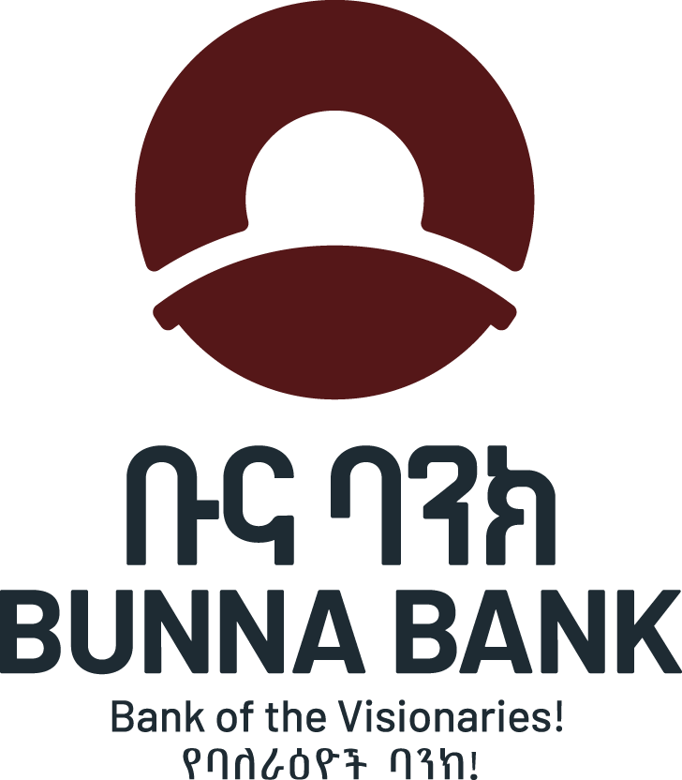

Odoo Helpdesk Enhancement
Requirements

Contact Center Operation Team

CC & Digital Customer Acquisition Directorate

July 2026

Introduction
Nowadays, most of Contact Centers (CC) are using Omni/multi channel systems to enhance customer communication channels and to provide quality support. We are using Odoo Help Desk system which is actively working to record the daily customer requests and it lacks monitoring, analysis and reporting and other basic required functionalities.

To provide efficient and effective support we need updated basic required modules and additional enhanced modules. Here below are the requirements which enable us to deliver improved customer support and timely analysis & on time monitoring and reporting.

A Help Desk module in a Contact Center system is used to log, track, assign, resolve, and report customer issues and service requests. It enables agents to manage customer inquiries efficiently while ensuring compliance with Service Level Agreements (SLAs), improving customer satisfaction, and maintaining complete interaction history from initiation to closing of a customer case.

One of the basic module which is a Ticket Management, it is the core component of a Help Desk system and it enables the Contact Center to record, assign, track, escalate, and resolve customer requests efficiently while meeting service level commitments.

Below are the basic and recommended Ticket Management functionalities for a banking Contact Center/Help Desk.

Functionality | Description
1. Ticket Creation | Create tickets manually by agents or automatically from email, phone, chatbot, IVR, website, mobile app, CRM, and social media channels.
2. Unique Ticket Number | Automatically generate a unique reference number for each customer issue.
3. Customer Identification | Retrieve customer profile automatically from CRM or Core Banking using Account Number, CIF, National ID, Phone Number, or Digital Banking ID.
4. Ticket Categorization | Classify tickets by category, sub-category, product, service, department, and issue type.
5. Priority Management | Assign priorities (Critical, High, Medium, Low) based on business impact and urgency.
6. Ticket Assignment | Assign tickets automatically or manually to appropriate support teams or individuals.
7. Queue Management | Route tickets to different operational queues based on product, language, location, or skill set.
8. SLA Management | Monitor response time and resolution time against predefined Service Level Agreements.
9. Escalation Management | Automatically escalate overdue or high-priority tickets to supervisors or higher support levels.
10. Ticket Status Tracking | Track ticket lifecycle (New, Assigned, In Progress, Pending Customer, Pending Third Party, Resolved, Closed, Reopened).
11. Ticket Ownership | Record the responsible staff member handling the ticket at every stage.
12. Ticket History | Maintain complete audit trail of activities, updates, comments, and ownership changes.
13. Internal Notes | Allow agents to add internal comments not visible to customers.
14. Customer Communication Log | Record all customer communications including calls, emails, SMS, chat, and social media interactions.
15. Attachment Management | Upload and store documents, screenshots, voice recordings, PDFs, images, and supporting files.
16. Resolution Management | Record root cause, resolution details, corrective actions, and preventive actions.
17. Reopen Ticket | Allow reopening of resolved tickets if the issue persists.
18. Duplicate Ticket Detection | Detect duplicate complaints and link them to existing tickets.
19. Parent-Child Tickets | Link related incidents or multiple tickets under one master ticket.
20. Knowledge Base Integration | Recommend knowledge articles or FAQs while handling tickets.
21. Related Customer History | Display previous complaints, interactions, and resolutions for the customer.
22. Multi-Channel Ticket Capture | Create tickets from phone, email, web portal, chatbot, WhatsApp, Telegram, Facebook, Instagram, SMS, and mobile banking.
23. Workflow Automation | Automate routing, approvals, notifications, and status changes.
24. Notifications & Alerts | Send automatic notifications to customers and staff via SMS, Email, Push Notifications, or Telegram.
25. Customer Acknowledgement | Send ticket confirmation with ticket number immediately after registration.
26. Ticket Search | Search by ticket number, customer, phone number, account number, date, status, or keyword.
27. Bulk Ticket Update | Update multiple tickets simultaneously by supervisors.
28. Ticket Merge & Split | Merge duplicate tickets or split complex tickets into multiple tasks.
29. Root Cause Analysis | Capture issue causes to support trend analysis and continuous improvement.
30. Incident Classification | Classify incidents by operational risk, fraud, compliance, system issue, service request, or customer complaint.
31. Problem Management Linkage | Link recurring incidents to a common problem record for permanent resolution.
32. Task Management | Create sub-tasks for different departments working on the same ticket.
33. Approval Workflow | Route tickets requiring management approval or exception handling.
34. Customer Feedback Collection | Trigger post-resolution satisfaction surveys (CSAT/NPS).
35. Ticket Closure Validation | Ensure mandatory fields and customer confirmation (where applicable) before closure.
36. Audit Trail | Log every action performed on a ticket for compliance and regulatory purposes.
37. Security & Access Control | Role-based access to create, view, edit, assign, and close tickets.
38. Dashboard & Reporting | Real-time dashboards for ticket volumes, SLA compliance, backlog, aging, escalations, and productivity.
39. Analytics & Trends | Analyze recurring issues, service quality trends, and operational bottlenecks.
40. Integration Capabilities | Integrate with CRM, Core Banking, Digital Banking, Contact Center, Email, SMS Gateway, Identity Management, and Knowledge Base systems.

Regarding over all modules for the Contact Center the team would prefer to have the functionalities recommended to have a standard Contact Center Help Desk Module. By considering our gaps, we are requesting the following customized requirements as first phase enhancements based on our practical assessment and challenges to deliver effective support to our customers.

No | Functionality | Requirements
1 | Admin Modules | The admin module expected to enable us to manage Users and Profiles, Work units and teams of the Bank to have first level and second level segregation of duties;
1.1 | Organization (Work Units and Teams) | To manage internal work units’ and respective teams. That means the system need to allow us to register HO work units, teams, districts and branches.
1.2 | Users | To register and manage internal users’ information under each work unit/team, including names, roles, phone numbers. It can fetch staffs’ data from Active directory of the Bank or it can be imported in bulk and then managed one by one when update is requested.
1.3 | User Profile | To create user profile and appropriate access under each user profiles.
2 | Help Desk Module | It is the core component of a Help Desk system. We expect it to enable the Contact Centre to record, assign, track, pend (wait), escalate, reassign, resolve, close and reopen customer requests or issues efficiently while meeting service level commitments.
2.1 | Ticket Management Module | - Automatic ticket generation integrate with the call management system (Queue metrics, if possible). Otherwise Manual ticket creation by CC agents or end users (internal or external).  - Ticket Creation: create tickets from phone calls, email, chat, social media, mobile app, or web portal.  Ticket Classification  - Unique ticket/reference number is mandatory;  - Ticket categorization and sub-categorization such as Categorize tickets by product (Account modification, Mobile, USSD products TeleBirr, Account Transfer…), Service (ATM, ITM, Digital Onboarding …), issue type (ATM Dispute, A2A …), Priority levels (Critical, High, Medium, Low), and customer segment.  - Product/Service selection: list products or services for each case;  - Fetch and update customer information per each ticket creation;  - Team and Agent selection; lists the team or division members under the selected work unit to assign case if manually assigned.  - Case type Selection: Complaint, Inquiry, Service Request, Incident, Technical/System Issue, Fraud Alert, Suggestion, Feedback and others.  - Customer identification/segmentation (if possible based on the account no from Finacle CRM) It can be fetched based on the customer information such as phone no or account no.  - Communication Channel: lists communication channel used for case or request initiation, or used by Contact Center to receive customer requests. Phone, Chatbot, Email, Whatsup/Telegram bot, Portal request;  Note: We expect the system integrates with these channels so it automatically detects and populates the communication channel based on the way the customer's request is received.  Customer type: Internal (Branch/HO Work units/Districts) Customer  External Customer (New Customer (Prospect Customer), Existing Customer;  When a customer submits a request through a phone call, chat-bot, email, or any other communication channel, the system automatically identifies whether the customer is internal or external by matching the phone number, or other available customer information through integration with the Core Banking System (CBS).  (At least we expect the system at least to identify customers’ requests which are logged by Contact Center agents using phone number, account number, or other available customer information)  Language Tags: Amharic, English, AfanOromo, Trigiregna or other language; The system shall automatically identify the customer's selected language preference and populate the Language Tag field with the corresponding language tag.  - Ticket status update: a customer case ticket can be at one of the following status  - New - created request/issue initiated by user or logged by agent.  - Assigned – new ticket is auto assigned to agent or manually by the agent (self-assigned) or by manager.  - Escalated: new or assigned ticket can be escalated to other team or team member;  - Solved: the assigned/pending/re-opened ticket can be solved by the CC agents or other second level team members then such status update can be handled by the assigned agent/team member or CC manager or other team leaders;  - Pending: such assigned case needs further clarity, doc or other external pre requisites need to be fulfilled.  - Reopen case: ticket at solved status case can be reopened by customer (internal or external) or it can be opened by the CC agents based on the response from customers or on behalf of customers.  - Closed case: solved ticket should be closed automatically/manually by batch, after specified waiting period for customer feedback or reopening. Closed tickets can be reopened or updated any more.  - Ticket Update: enable the user/agent/team member to add notes, attachments, status updates, and for customer communications.  NOTE:  The case with Solved status, reopened since the customer not satisfied with the given solution or irrelevant action is taken by agents/other team members.  Customer Rating: when the case is closed the system enable the CC agents (on behalf of the customer) or the customer to express satisfaction level based on the feedback provided. (Very Satisfied, Satisfied, Un Satisfied, Very Poor, Neutral). If not possible the system automatically rates each case as Satisfactory when the case is closed in batch for specified date by CC agent.  Description change to Customer Inquiry or Customer Inquiry Formulation: system should integrate with an AI-powered grammar and spelling checker to help users create accurate and professional case descriptions and responses based on the customer call. (If direct transcription and automatic description generation is not possible)
3 | Dashboard | The system expected to provide a dashboard that enable us to manage the daily routines effectively and it expected to contains, at minimum, the following components with required details:  Overall help desk performance:  Total tickets, Open tickets, Closed tickets, SLA compliance, Customer Satisfaction (CSAT), First Contact Resolution (FCR), Average Resolution Time;  Note: Open Tickets include New - created request/issue by user or logged by agent), Assigned – new ticket assigned to agent by manager or self-assigned by agent, Pending, Escalated, solved; Only Closed ticket is not included for the dash board. Closed tickets need to be retrieved by reports.  Agent and Team Performance: it displays for specific period (weekly/bi weekly), open tickets i.e assigned and resolved by each CC agent and escalated team members as well as team level;  If Possible Evaluate agent productivity: Tickets handled, Average Handle Time (AHT), First Contact Resolution, After Call Work (ACW), Occupancy rate, Utilization rate, Quality score  Categorized Cases by Service/Products: it displays categorized cases status for specific period (weekly/bi weekly)  - Cases received by different channels and status of each cases; It can be filtered by specific period with various status for each case.  - Filtering cases by service and/or product;  - Cases by CC team or second level work units (Directorates/teams) for each services or products support request;  Ticket Management Dashboard: New tickets, Assigned, In Progress, Pending Customer, Escalated, Resolved, Closed, Reopened for each CC agents and team members of other work units;  Top highest cases: system shall display daily/weekly top case types registered through both agents and other communication channels (e.g., Phone, Email, Tidio, and Customer Portal).  Priority Dashboard: tickets by urgency Critical, High, Medium, Low priority tickets  Track support channels: Calls, Email, Chat, WhatsApp, SMS, Social Media, Web Portal requests;  External Customer Dash board: external Customers tickets, average resolution time, most Frequently reporting issues, most frequently reporting customers;  Branch Support Dashboard/Internal customers or Branch and HO work units tickets, average resolution time, most frequently reporting issues, most frequently reporting branch;  Queue Performance Dashboard: to monitor workload: tickets by queue, Queue backlog, longest waiting ticket, Queue distribution;  Escalation Dashboard: for follow up critical issues escalated tickets, Escalation reasons, Aging escalations, Escalation by department.  SLA Performance Dashboard: SLA met %, SLA breached %, Tickets nearing SLA breach, Resolution time by priority
4 | Product/Service Catalogue Management  - Service/Product Family  - Service  - Service sub Category | Example: Service Family could be CBS Service: Conventional Products Service Sub Category Account Opening Case, Fayda Link Case, Account Name Maintenance, etc  Service Family could be Digital Products Service: Digital Financial Services Service Sub Category ATM card case, Telebirr Case, A2A Case, DFS loan disbursement case, DFS repayment case, etc  Service Family could be Digital Services Service: Digital Account Opening Service Sub Category Account Opening Case, Phone number case,  Service Family Digital Transaction/Dispute Service: On Us ATM Case Service Sub Category On Us ATM Dispute, On Us ATM Settlement, Mobile APP Transfer Case, USSD Transfer Case, Service :- A2A Transaction, Incoming A2A, Outgoing A2A, Off us ATM Dispute.
5 | Service provider Mgmt Module  (Service model) | Internal service providers which are the CC and second level teams. Eg. Contact Center, Digital banking operation team, Core banking and auxiliary, Digital Banking application team and others to be mapped with the service they are going to provide.  Work unit or team member: - if CC team member or other work unit team member is absent from duty or not logged in to the system and not active enable the system to update such status and to automatically notify unavailable team member when the CC staffs or agents not to try to assign or escalate issues to inactive members or staffs.
6 | Complaint Management | It is required to handle customer Complaints Registration as per the NBE requirements. This module enables the team to segregate complaints from normal service request, issues or incidents. It is expected to have  Complaint Categorization, Complaint Investigation and follow up by Ethics team, Complaint Escalation, Complaint Resolution, Regulatory Complaint Tracking and customer update.
7 | Contacts Management Modules | It expected to categorize assigned staffs form each work units for services, especially in case of escalated services to map primary contacts. That means to map agents or other team members with the especial Service they are assigned to provide.
8 | Customer Information | Customer Information  • Customer profile lookup or fetching existing customer information for effective support. Such information can be  • CIF, Account search  • Contact information  • Customer history  • Relationship type  •Customer segmentation (Retail, SME, Corporate, VIP, Youth )
9 | Operational level agreement (OL A or SLA) Management | Set Rule and Policy: Defines the rules, responsibilities, and agreements between the CC Team and the second level or Service Provider team regarding response times for escalated cases.  Service delivery time: it enables to define SDT for each service or we need to define average resolution time or SLT or SDT. It can be measured in minutes or seconds and can go up to hours or day(s).  - List Service Family Sub service for selection;  - Allow to set Resolution time for specific service (Service Level Targets (SLT) or Service delivery Time (SDT);  - Select responsible Work unit or team which is responsible for the SDT;  - Active/Inactive: if the service/product is obsolete the SDT not to be referred when the agent logs customer requests;  - OLA Document upload: the OLA signed document need to be upload.  - Other related and required information can be captured.
10 | Escalation Mgmt  Notification:  Alert/Warnings/SMS/Email | For BB CC we can have two levels. The first level (CC operation team) and second level which means other work units of the Bank who are resolving escalated issues.  Escalation Level: Defines the appropriate work unit, team, or department to which a case is assigned after it has been escalated for further resolution.  Notification: -  - Sends email or SMS notifications to the relevant users when a case is escalated from Contact Center to respective work unit, or to assigned team member from that work unit.  -Notifies the customer via SMS or email when a case has been resolved, using the customer's preferred notification method.  -Automatically notifies the Contact Center through Odoo when the respective work unit has successfully resolved an escalated case.  Alert: Notifies the relevant users when the response time for an escalated case reaches its due date or expires
11 | Knowledge Base Management | Central library for storing support articles, SOPs, manuals, FAQs, and troubleshooting guides from different work units.  It can be managed by the CC agents as well as other work unit or team members.  Category: It can be categorized by sub service, product types.  Work unit: - list to select work unit who defines the resolution methods for each service, product or case type under the responsible work unit to take accountability. It can be approved by the respective work unit team leader or manager. It helps to provide guidance for resolving customer issues.  Articles creation: - Enables any work unit to create and publish articles about new product features, services, issue resolution methods, troubleshooting guides, and other relevant information.  It enables as to manage active or obsolete items or articles to make invisible for the end users or agents/team members.
12 | Third party Integration | Current integration in Odoo  - Softphone  - Contact center email request  - Chatboat (Tidio)  - portal request (on boarding, feedback)  - Core banking (CRM), and  - Other mandatory channel  When the Contact Center introduces a new channel, the system is designed to easily accept and integrate it.  Core banking (CRM)  When an existing or internal customer calls, the system automatically retrieves and populates the customer's basic information in Odoo case management system, including their name, phone number, branch, account number, and other available details.
13 | Reporting Module  (View using Filtering Parameters and exporting in Excel, CSV and pdf formats | Repots: Daily, Weekly, monthly, Quarterly, Semi-annual, Annually  The system should generate different reports with various requirements. Templates to be communicated in short time as other document.
14 | Multi-Channel Support | The CC system is expected to allow multiple channels communication from customers. We expect the system to support at least Phone conversation transcription (integrated with the Queue-Metrics), Email requests or, Web Form requests from other integrated systems such as Digital On boarding, Mobile App and others, Chat from Chat boat (we are currently using Tidio from the Website) and other possible social media channels such as WhatsApp. Facebook Messenger, Telegram, SMS.

